

**Quick Guide to Research Data Finder**

Research Data Finder is QUT’s registry of **research data assets, both digital and physical** (such as geological samples) which have been created or collected by QUT researchers. Research Data Finder enables researchers to provide descriptions about their data and create **unique identifiers** (Digital Object Identifiers [DOIs]) to track data citations.

**Software Finder** and **Spatial Data Finder** are two collections within Research Data Finder, which list descriptions of source code and binaries, and spatially-referenced data, respectively.

Information about data collections, researchers or research groups, publications and projects are exposed to a **wider audience** through Research Data Australia, the Australian registry of research data.

### How do I contribute to the registry?

Simply log in to Research Data Finder using your QUT username and password and answer a few questions. Your draft records will be checked by Library staff then published for other researchers to view.

Go to <https://researchdatafinder.qut.edu.au> and click on *QUT Login.*

In the *Add new record box,* select the type of record you wish to add e.g. to add a description of a data set, select *Research data set*. Use the descriptions to guide your selection.

Give your record a title and complete the mandatory fields on the next screen. Also complete the optional fields if applicable. Click on *Send for review*.

### Go to *Manage records*

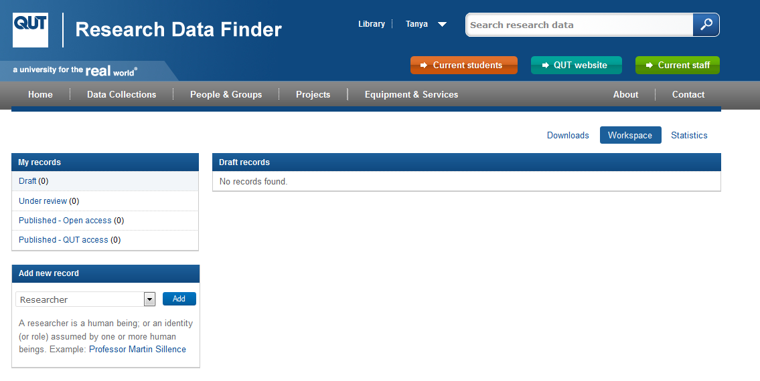

Records can be published as:

1. *Open access*

(public) or

1. *QUT access* (QUT staff and students)

### Select the type of record you wish to add

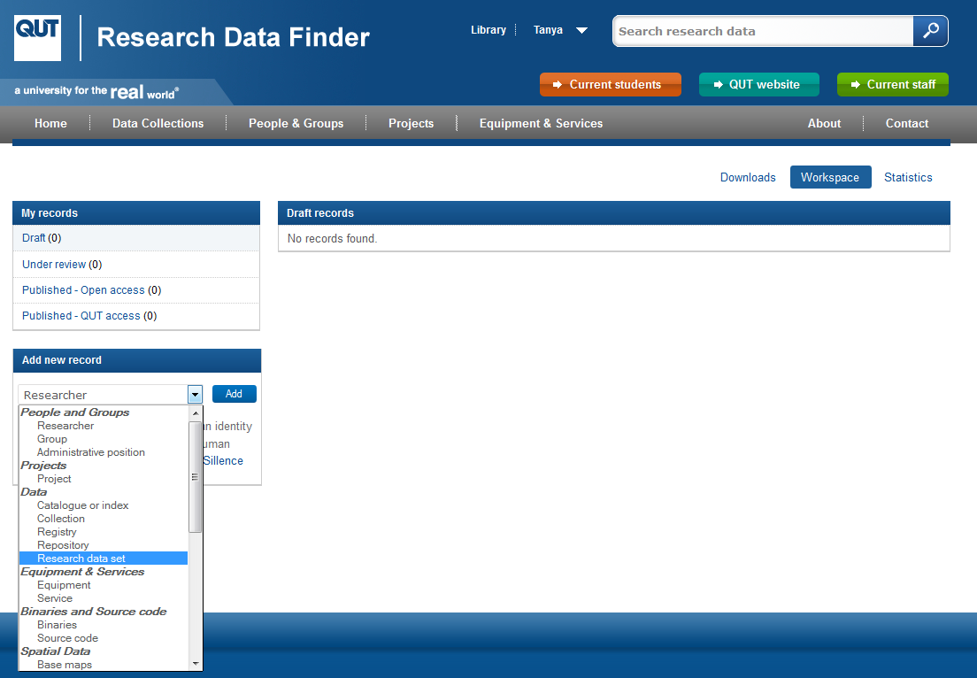

To create records in Software Finder, select *Binaries* or *Source code.*

To create records in Spatial Data Finder, select a category under *Spatial Data*.

### Give the record a title

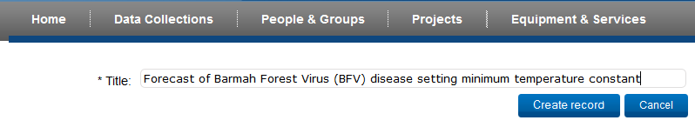

### Complete the mandatory fields

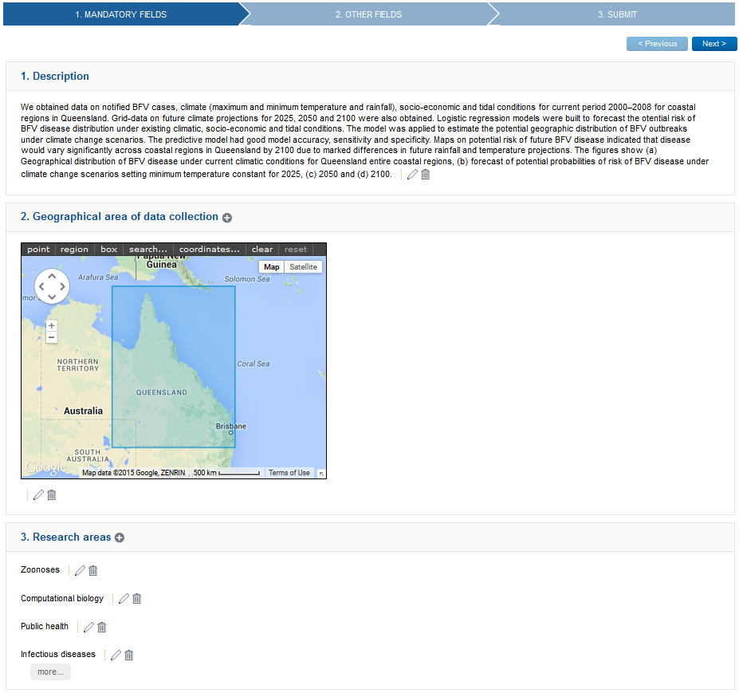

Click the ‘+’ symbol to add another entry for the field

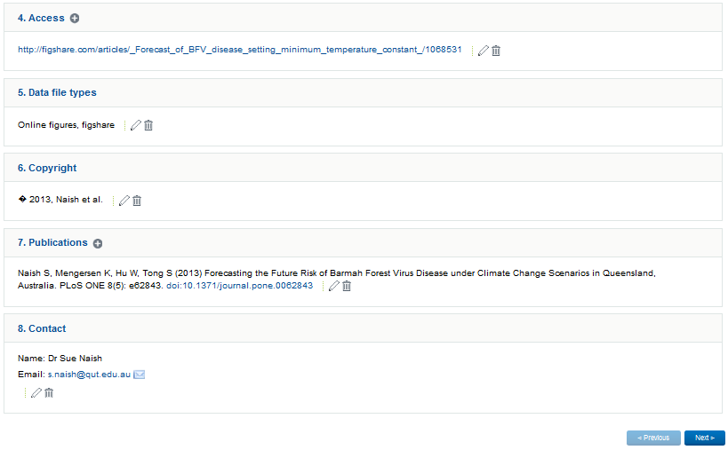

Click to edit or delete

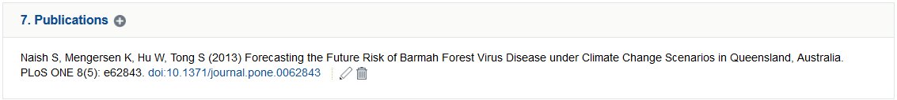

### Complete other fields, if applicable

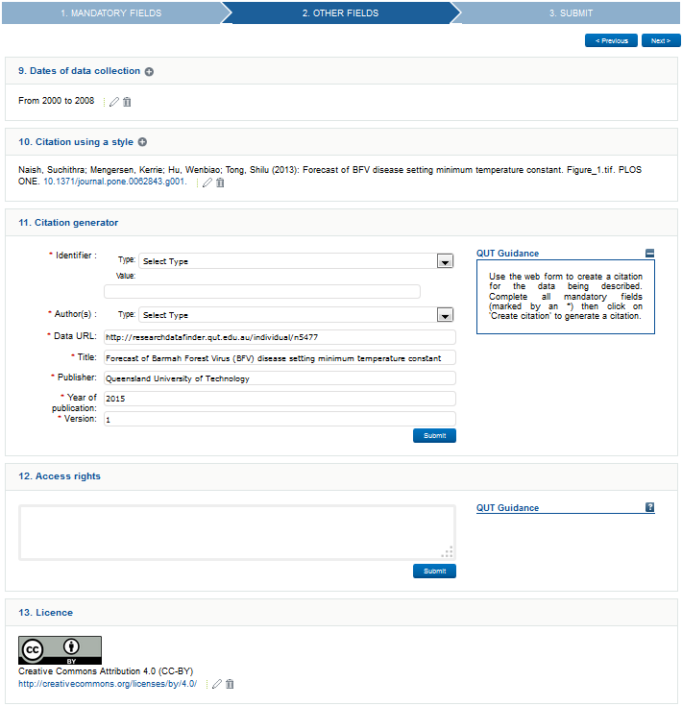

Click *Previous* or *Next* to move between screens

Guidance is available for both mandatory and other fields

Remember to click *Submit* after completing each field

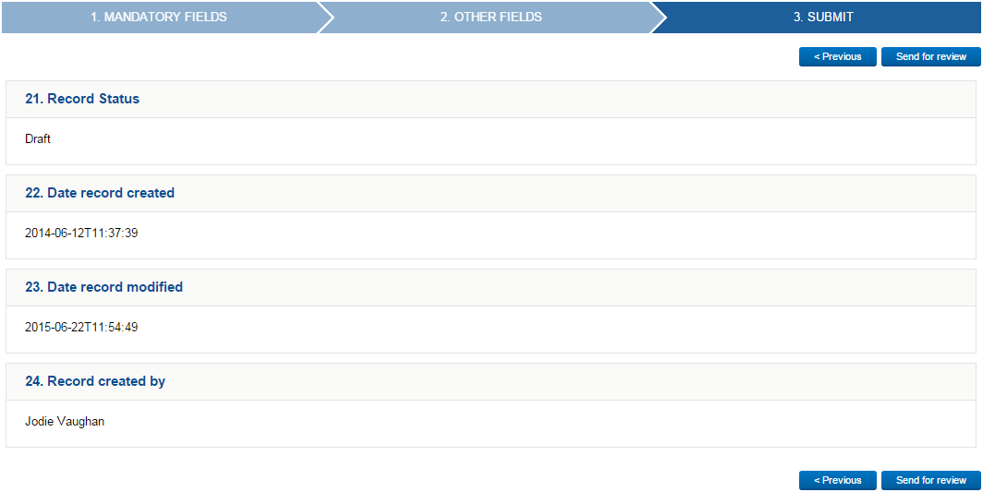

Click *Send for review* once your record is ready to be published

Guide to Research Data Finder by QUT Library is licensed under a Creative Commons Attribution 4.0 International License. 30 June 2015. 